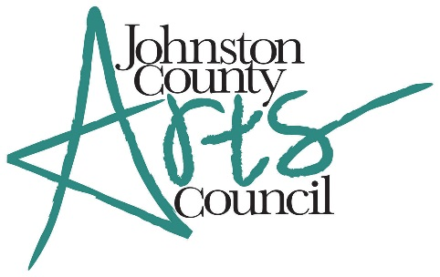

**Eighth Annual Art and Food Festival**

**Thursday - March 16, 2017**

**Art Show**

March 6, 2014

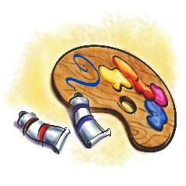

**The Eighth Annual Johnston County Art and Food Festival** features signature dishes from several local restaurants and artists’ works in painting, pottery, and photography categories vying for awards.

All artists who enter artwork will receive a ticket to the event ($40 value). Additional guests may purchase tickets by contacting the Johnston County Arts Council office at 919-938-0306, by emailing us at [info@jcartscouncil.org](mailto:info@jcartscouncil.org), or by contacting any JCAC board member.

**CALENDAR:**

* All entry forms, along with the $40 entry fee, must be received by **March 3, 2017,** in order to be included in the Directory of Artists (new this year).
* Notification will be sent to the artist no later than **March 10, 2017**.
* Delivery of artwork will be the day of the event, **Thursday**, **March 16, 2017**, from 11:00 am until 1:00 pm at the Paul A. Johnston Auditorium (JCC), located at 269 College Road, Smithfield, NC.
* Pick up all artwork at the end of the event at 8:00 pm. The Arts Council will not be responsible for artwork not picked up the night of the event.

**CATEGORIES:**

Original artwork must have been completed within the past three years and not previously awarded a prize at the Art and Food Festival to be eligible for the exhibit. Artists must be 18 years of age or older and live in North Carolina.

***PAINTING CATEGORY***: oils, acrylics, watercolors, colored pencils, pastels, pencil, charcoal, and pen and ink.

***MIXED MEDIA***: mosaics, collages, assemblages, any artwork that incorporates three-dimensional objects like cut-up paper or art that combines media such as acrylics, oils, crayons, and/or pencils together.

***PHOTOGRAPHY:*** artistic photography, digital or traditional. including nature, portrait, and still life

***POTTERY:*** original pieces only, hand-built (no commercial slip cast ceramic mold pieces), wheel thrown, sculpture, may be functional or non-functional, all themes, genres and types of clay accepted, no larger than 12” wide or deep, and no more than 24” tall

***Note: The Johnston County Arts Council reserves the right to photograph all entries and use any images for publicity or reject any entry that is deemed not suitable for display.***

**Awards (given per category)**

* 1st place: $200
* 2nd place: $100
* 3rd place: Ribbon
* Honorable Mention: Ribbon

**BEST OF SHOW: $300**

(one winner will be determined by the judges from all entries)

**Sales**

All sales will be payable to the artist and the artist will remit a commission of 10% to JCAC. Artwork not for sale should be marked “NFS.” We **will not** accept tags marked “Price upon Request.”

**Display of work**

Pottery will be placed on a display table, unless artist provides pedestal. The JCAC will not be responsible for damaged or broken pieces. All other artwork must be framed and securely placed on artist-provided easels. Work on canvas with finished edges is acceptable. No frames with exposed glass edges will be accepted. Entries should not exceed 48” in any direction (including frame).

**Entry Instructions**

* Complete the entry form. Make sure all information is filled out.
* Include your check made payable to Johnston County Arts Council (JCAC) or provide evidence of using PayPal at our JCAC website: [www.jcartscouncil.org](http://www.jcartscouncil.org).
* Mail your entry form and check or proof of PayPal payment to the following address:

**Johnston County Arts Council**

**PO Box 2019**

**Smithfield, NC 27577**

All entry forms/payments must be received by **March 3, 2017**.

**Liability**

JCAC is not responsible for theft or damage to art entries, including nicks to frames, breakage of glass, or scratches to Plexiglas. Artist is responsible for any insurance deductible.

There will be a **Silent Auction** for donated art pieces during the event to benefit the Artists-in-the-Schools program for Johnston County Schools. If you would like to donate any artwork to this auction, the JCAC would be happy to accept.

**Thank you!**