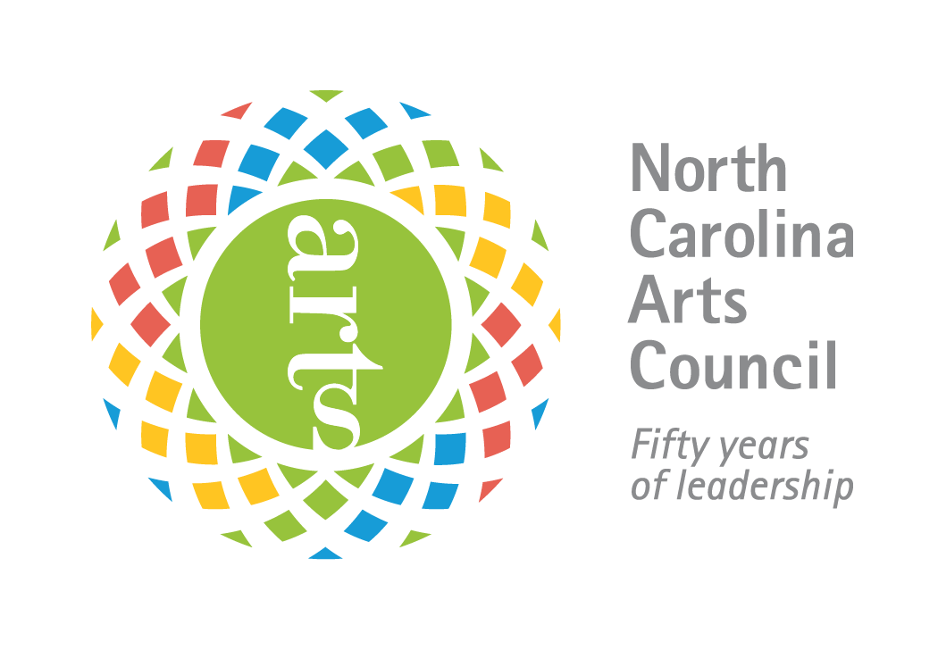
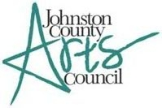

Guidelines for Grassroots Arts Program Subgrants

Since 1977, the N.C. Arts Council’s Grassroots Arts Program has provided North Carolina citizens access to quality arts experiences. The program distributes funds for the arts in all 100 counties of the state primarily through partnerships with local arts councils. Johnston County Arts Council serves as the NC Arts Council’s partner in awarding subgrants to local organizations for arts programs in Johnston County.

Eligibility for Application
• All organizations must have been in operation for at least one year. While nonprofit 501(c)(3) status is preferred, organizations that are nonprofit in nature may also apply.
• All organizations must reside and carry out projects within the county they are applying for funds.
• Individuals are not eligible to apply for Grassroots Arts funds.
• Applications and support materials must be completed and received by the due date.
• All projects must take place between July 1, 2023 and June 14, 2024.
• Grant amounts range from $500 and up.
• Original and 4 copies should be sent to Johnston County Arts Council, PO Box 2019, Smithfield, NC 27577.
• Must include a financial statement

Application Submission & Deadline
All applications must be received by Johnston County Arts Council by Friday- August 18, 2023 at 5pm. Applications must be mailed or hand delivered, fax submissions will not be considered. The mailing address is: PO Box 2019 Smithfield, NC 27577
The physical address for deliveries is : 1115 Outlet Center Drive, Smithfield, NC 27577.

What the Grassroots Arts Program Funds
Grassroots Arts Program funds may be used for expenditures to conduct quality arts programs or operate an arts organization. Typical uses of Grassroots money include:
• Program expenses such as professional artists’ fees and travel, space rental, advertising, marketing and publicity, website and electronic media, scripts, costumes, sets, props, music and equipment rental.
• Operating expenses for qualified arts organizations not already receiving operating support from the N.C. Arts Council. These can include salaries, telephone, office supplies, printing, postage, rent, utilities, insurance and equipment rental.

Priorities for Funding
The first priority of the Grassroots Arts subgrant program is to provide operating or program support to qualified arts organizations not already receiving or eligible to receive support from the N.C. Arts Council. These include theaters, symphonies, galleries, art guilds, choral societies, dance companies, folk arts societies, writers’ groups and arts festivals, among others.
The second priority of the Grassroots Arts subgrant program is to support arts learning and arts in education programs conducted by qualified artists. These can be artist residencies in schools, afterschool or summer camps or adult arts learning classes.
The third priority of Grassroots Arts subgrants is to community, civic and municipal organizations. These programs must be conducted by qualified artists.
Funding Policies
• Tribal organizations that receive Grassroots funds must represent state or federally recognized tribes.
• Colleges, universities and libraries may receive grants for arts programs that are community-based or generate regional arts involvement. Grants may not support their internal programs, administration or operation expenses (library books, band boosters, equipment purchases).
• Grassroots funds may not be awarded to individuals or to organizations for prizes, competitions, tuition, or financial rewards.
• Grassroots funds may not be used for art supplies or equipment.
• Religious organizations or churches may not receive Grassroots funds unless the programs are presented outside regular church services, engage the larger community and do not contain religious content.
• Grassroots funds may not be used for activities associated with a school’s internal arts programs such as in-school student performances, the purchase of art supplies, or student arts competitions and publications.
• Municipalities (city/county governments) may receive grants for arts programs which use qualified artists to conduct programs that involve the greater community. Grants may not support internal programs, administration or operating expenses.
Grassroots Arts Program money may not be used for the following kinds of expenditures:
•Art, music, and dance therapists •Fundraising events
•Artifacts •Purchase artwork
•Purchase equipment or art supplies •Oral history and history projects
•Capital expenditures or equipment •Tuition for academic study
•Contingency funds •Interest on loans, fines, or litigation costs
•Deficit reduction •Lobbying expenses
•School band activities or equipment •School choral activities
•Food or beverages for hospitality or entertainment function

Grassroots Arts Program Subgrant Requirements
Matching Requirement
All subgrantees must match their grant amounts dollar for dollar. The funds must come from other public or private sources. Other N.C. Arts Council funds cannot be used as a match.

North Carolina Arts Council Recognition
Subgrantees must acknowledge the N.C. Arts Council’s support of their event or projects by including the N.C. Arts Council’s logo, and funding credit line in all print and promotional materials related to the grant. The N.C. Arts Council’s website offers information and downloadable logos at http://www.ncarts.org/Grants/Logo-Use

Reporting Requirements
Each subgrantee is required to submit a final report providing a detailed description of the funded project, participation statistics and demographics, sample marketing and program materials using the N.C. Arts Council credit line and logo, and copies of their legislative letters. The Subgrant Report form can be downloaded from the N.C. Arts Council Web site at: http://www.ncarts.org/resources/local-council-resources. Look for FY 2023–2024 final report for Grassroots Subgrantees. Subgrant Report Forms should be submitted to the Johnston County Arts Council by June 18, 2024.

Legislative Letters
Applicants are required to write their state representatives to thank them for appropriating Grassroots funds. The letter should provide information about how Grassroots funds were used to support your program or project, and the community impact of the event. A copy of all letters to legislators must be included in the final report materials.

How Subgrant Applications Are Evaluated
Subgrant applications are reviewed by a diverse panel of community members including artists, county and public officials and arts council board members among others. The panel evaluates each application based on the subgrant guidelines and the following criteria:
•Artistic quality of proposed project or programs
•Community impact of project or programs
•Ability to plan and implement project
•Stability and fiscal responsibility of the organization

Panelists discuss and score the grant using an established rating system. The subgrant panel’s funding decisions are then presented as recommendations to the Arts Council board of directors. The board of directors votes and gives final approval to the subgrant panel’s recommendations.

Questions and Assistance
If applicants have questions or need assistance, please contact Darlene Williford, Executive Director at
info@jcartscouncil.org or call (191) 738-9622

