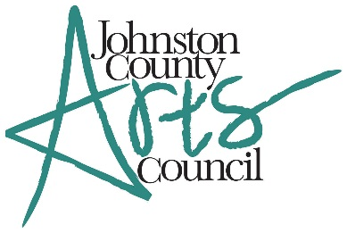
Art Entry Form
Ninth Annual Art & Food Festival
Mail this form and the entry fee ($40) to the address at the bottom of this page by March 2, 2018. Fee can be paid by check or paid through PayPal on the Johnston County Arts Council website at: www.jcartscouncil.org. Submit one Art Entry Form for each piece of art.
Please print legibly
Artist Name:
Address:
Phone Number: Email:
Art Entry
Title of Piece:
Medium:
Price (if applicable) or NFS: $
(Size should not excel 48” in any direction, including frame. Artist is responsible for supplying an easel to display art. If submitting pottery, pieces will be displayed on a table unless artist provides a pedestal.)
Agreement: Submission of work to this exhibit will constitute an agreement to comply with all rules, conditions and requirements of the Art & Food Festival. Johnston County Arts Council (JCAC) reserves the right to photograph and use images of the event. JCAC also reserves the right to reject any work deemed not suitable for display.
Artist Signature:
Send entry from and fee to:
Johnston County Arts Council
PO Box 2019
Smithfield, NC 27577

Would you consider donating an art piece for the Silent Auction? All proceeds will benefit the Artists-in-the-Schools program.
Will you be donating an artwork? YES NO
Description of Donation:
Media: Value: $

